IDTS Change request:
Date: 16 Sep 2009
Attendees: James Tang, Sasha, Maizan, Wei Ling, Pei Fong

- Despatch – Change header name TIME CALL to APOF Print Time
-Include Screen and report changes

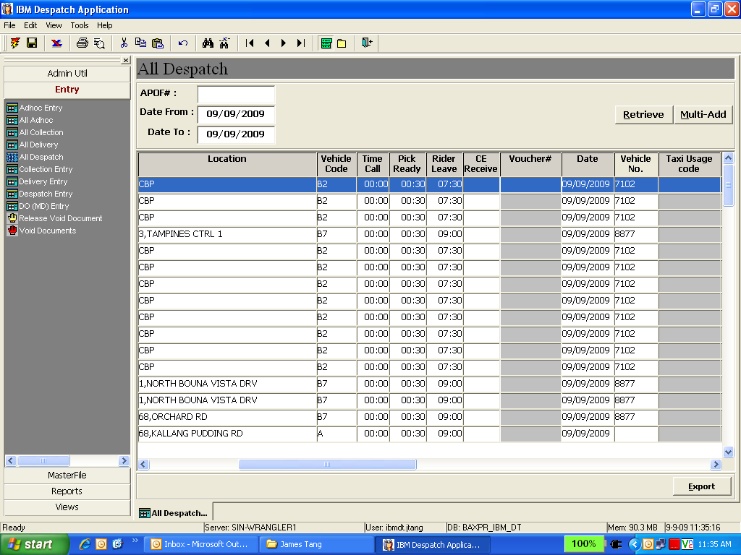
Pls change the title name from Time Call to APOF print Time

2. ASAP TAT Report
To add in Picker TAT, Despatch TAT
This is the report which we manual key in every week to determine the Picker TAT, Despatch TAT, Rider TAT, Total TAT
Calculation:
Picker TAT = Pick Ready time – Time Called Time = 5mins
Despatch TAT = Vehicle leave time – Pick Ready time = 10mins
Rider TAT = Ce Receive time – Vehicle leave time = 45mins
Total TAT = Ce Receive time – Time Called Time = 60mins (Our contractual KPI agreement with IBM for ASAP orders)

